SETUP LOYALTY

1. Add account type

* Navigate ROOT\OpenWay\Full\Configuration Setup\Accounting Setup\Account Types
  1. “Bonus Temporary” account type is used to store the temporary point
* Select “Bonus”
* Update values
  + Name: Bonus Temporary
  + Due Type: End Cycle Due
* Click “Save form changes”
  1. “Bonus Available” account type is used to store the available point
* Click “Insert new record”
* Input values
  + Product: Issuing
  + Name: Bonus Current
  + Account Role: Bonus
  + Category: Other
  + Is Am Av: No
  + Due Type: Sliding
  + Code: B2
  + Priority: 0
* Click “Save form changes”
  1. “Bonus Spending” account type is used to store the spending point
* Click “Insert new record”
* Input values
  + Product: Issuing
  + Name: Bonus Spending
  + Account Role: Bonus
  + Category: Other
  + Is Am Av: No
  + Due Type: None
  + Code: B3
  + Priority: 0
* Click “Save form changes”
  1. “Bonus Expiration” account type is used to store the expiration point
* Click “Insert new record”
* Input values
  + Product: Issuing
  + Name: Bonus Expiration
  + Account Role: Bonus
  + Category: Other
  + Is Am Av: No
  + Due Type: None
  + Code: B4
  + Priority: 0
* Click “Save form changes”

1. Add Custom Handbooks

* Navigate ROOT\OpenWay\Full\Configuration Setup\Client Classifiers\Standard Handbooks
* Click “Insert new record”
* Input values
  + Handbook Type: OCB_LYP_EXC_MN_LIST
  + Filter Value: PAYPAL
  + Data Value: PAYPAL
* Click “Save form changes”
* Do the same with values ZALOPAY, MOMO, AIRPAY, ALEPAY, NGANLUONG, VIMO, MOCAVN, VNPAY, SKRILL

1. Add Preference Type

* Navigate ROOT\OpenWay\Full\Configuration Setup\Products\Product Definition\Preference Types
* Click “Insert new record”
* Input values
  + Name: Loyalty Point Conditions
  + Code: LYP_CONDITIONS
  + Contract Cat: Card
* Click “Save form changes”

1. Add SIC Group & SIC Code

* Navigate ROOT\OpenWay\Full\Configuration Setup\Main Tables\SIC Groups
* Click “Insert new record”
* Input values
  + Name: OCB LYP Exceptions
  + Group Code: OCB_LYP_EXC
* Click “Save form changes”
* Navigate ROOT\OpenWay\Full\Configuration Setup\Main Tables\SIC Codes
* Select Code=7800 & Click “Direct Group” 🡪 Open “Direct Group for …” form
  + Click “Insert new record”
  + Input values
    - SIC Group: OCB LYP Exceptions
  + Click “Save form changes”
  + Close form
* Do the same with values 7801,7802,9406,7993,7994,7995,5816,7311,7321,7333,7338,7339,7342,7349,7361,7372,7392,7393,,7394,7395,7399,7523,0763,0780,1520,1711,1731,1740,1750,1761,1771,1799,9211,9222,9223,9311,9402,9405,9399,5960,5962,5966,5967,5968,5969,5541,5542,5983,5172,4829,6010,6011,6012,6050,6051,6211,6513,6532,6533,6536,6537,6538,6540,2741,2791,2842,5021,5039,5044,5046,5047,5051,5065,5072,5074,5085,5094,5099,5111,5131,5137,5139,5169,5198,5199,7375,7379,7829

1. Setup Tariff Domains

* Navigate ROOT\OpenWay\Tariffs\Tariff Types & Tariff Domains\Tariff Domains
* Select “Issuing Credit Card” & Click “Preferred” 🡪 Open “Preferred for …” form
  + Click “Insert new record”
  + Input values
    - Preference Type: Loyalty Point Conditions
  + Click “Save form changes
  + Click “Full Info” 🡪 Open “Full Info for …” form
    - Update values
      * Custom Parms: EXC_SIC_GROUP_LIST=OCB_LYP_EXC;
    - Click “Save form changes”
    - Close form
  + Close form
* Select “Issuing Credit Card” & Click “Sub Domains” 🡪 Open “Sub Domains for …” form
  + Select “MasterCard Credit Card” & Click “Sub Domains” 🡪 Open “Sub Domains for …” form
    - Select “OCB MC Credit Card Gold” & Click “Tariff” 🡪 Open “Tariff for …” form
      * Select “MC Credit Gold Loyalty Score”
        + Update values

If Preference Type: Loyalty Point Conditions

* + - * + Click “Save form changes”
      * Close form
    - Select “OCB MC Credit Card Standard” & Click “Tariff” 🡪 Open “Tariff for …” form
      * Select “MC Credit Standard Score”
        + Update values

If Preference Type: Loyalty Point Conditions

* + - * + Click “Save form changes”
      * Close form
    - Select “OCB MC Credit Card Platinum” & Click “Tariff” 🡪 Open “Tariff for …” form
      * Select “MC Credit Platinum Score”
        + Update values

If Preference Type: Loyalty Point Conditions

* + - * + Click “Save form changes”
      * Close form
    - Select “OCB MC Credit Card Gold Priority” & Click “Tariff” 🡪 Open “Tariff for …” form
      * Select “MC Credit Gold Priority Loyalty Score”
        + Update values

If Preference Type: Loyalty Point Conditions

* + - * + Click “Save form changes”
      * Close form
    - Close form
  + Select “JCB Credit Card” & Click “Sub Domains” 🡪 Open “Sub Domains for …” form
    - Select “OCB JCB Credit Card Standard” & Click “Tariff” 🡪 Open “Tariff for …” form
      * Select “JCB Credit Standard Score”
        + Update values

If Preference Type: Loyalty Point Conditions

* + - * + Click “Save form changes”
      * Close form
    - Select “OCB JCB Credit Card Gold” & Click “Tariff” 🡪 Open “Tariff for …” form
      * Select “JCB Credit Gold Loyalty Score”
        + Update values

If Preference Type: Loyalty Point Conditions

* + - * + Click “Save form changes”
      * Close form
    - Select “OCB JCB Credit Card Platinum” & Click “Tariff” 🡪 Open “Tariff for …” form
      * Select “JCB Credit Platinum Score”
        + Update values

If Preference Type: Loyalty Point Conditions

* + - * + Click “Save form changes”
      * Close form

1. Setup Tariff Data

* Navigate ROOT\OpenWay\Tariffs\Tariff Data Input By Domain Tree
* Select “Issuing Credit Card” & Click “Sub Domains” 🡪 Open “Sub Domains for …” form
  + Select “MasterCard Credit Card” & Click “Sub Domains” 🡪 Open “Sub Domains for …” form
    - Select “OCB MC Credit Card Gold” & Click “Tariff” 🡪 Open “Tariff for …” form
      * Select “MC Credit Gold Loyalty Score” & Click “Tariff Data” 🡪 Open “Tariff Data for …” form
        + Click “Insert new record”
        + Input values

FX Rate Type: Middle

Currency: LYP

Fee Rate Pcnt: 0.033

* + - * + Click “Save form changes”
        + Close form
      * Close form
    - Select “OCB MC Credit Card Gold Priority” & Click “Tariff” 🡪 Open “Tariff for …” form
      * Select “MC Credit Gold Priority Loyalty Score” & Click “Tariff Data” 🡪 Open “Tariff Data for …” form
        + Click “Insert new record”
        + Input values

FX Rate Type: Middle

Currency: LYP

Fee Rate Pcnt: 0.033

* + - * + Click “Save form changes”
        + Close form
      * Close form
    - Select “OCB MC Credit Card Platinum” & Click “Tariff” 🡪 Open “Tariff for …” form
      * Select “MC Credit Platinum Score” & Click “Tariff Data” 🡪 Open “Tariff Data for …” form
        + Click “Insert new record”
        + Input values

FX Rate Type: Middle

Currency: LYP

Fee Rate Pcnt: 0.033

* + - * + Click “Save form changes”
        + Close form
      * Close form
    - Select “OCB MC Credit Card Standard” & Click “Tariff” 🡪 Open “Tariff for …” form
      * Select “MC Credit Standard Score” & Click “Tariff Data” 🡪 Open “Tariff Data for …” form
        + Click “Insert new record”
        + Input values

FX Rate Type: Middle

Currency: LYP

Fee Rate Pcnt: 0.033

* + - * + Click “Save form changes”
        + Close form
      * Close form
  + Select “JCB Credit Card” & Click “Sub Domains” 🡪 Open “Sub Domains for …” form
    - Select “OCB JCB Credit Card Gold” & Click “Tariff” 🡪 Open “Tariff for …” form
      * Select “JCB Credit Gold Loyalty Score” & Click “Tariff Data” 🡪 Open “Tariff Data for …” form
        + Click “Insert new record”
        + Input values

FX Rate Type: Middle

Currency: LYP

Fee Rate Pcnt: 0.033

* + - * + Click “Save form changes”
        + Close form
      * Close form
    - Select “OCB JCB Credit Card Platinum” & Click “Tariff” 🡪 Open “Tariff for …” form
      * Select “JCB Credit Platinum Score” & Click “Tariff Data” 🡪 Open “Tariff Data for …” form
        + Click “Insert new record”
        + Input values

FX Rate Type: Middle

Currency: LYP

Fee Rate Pcnt: 0.033

* + - * + Click “Save form changes”
        + Close form
      * Close form
    - Select “OCB JCB Credit Card Standard” & Click “Tariff” 🡪 Open “Tariff for …” form
      * Select “JCB Credit Standard Score” & Click “Tariff Data” 🡪 Open “Tariff Data for …” form
        + Click “Insert new record”
        + Input values

FX Rate Type: Middle

Currency: LYP

Fee Rate Pcnt: 0.033

* + - * + Click “Save form changes”
        + Close form
      * Close form

1. Setup Service Pack

* Navigate ROOT\OpenWay\Full\Configuration Setup\Products\Service Packs
* Select “001-Add MC Credit Base”, “001-Add JCB Credit Base” & Click “Target” 🡪 Open “Target for … form”
  + Select Transaction Type=Retail/Unique & Click “Custom Fee” 🡪 Open “Custom Fee for …” form
    - Select Fee Curr=LYP & Click “Full Info” 🡪 Open “Full Info for …” form
    - Update as the below image

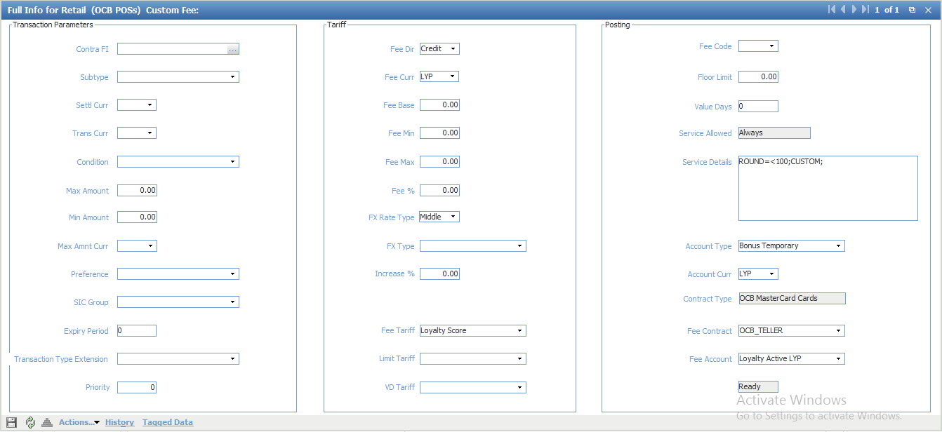

* + Select Transaction Type=Credit & Click “Custom Fee” 🡪 Open “Custom Fee for …” form
    - Create a new one as the below image

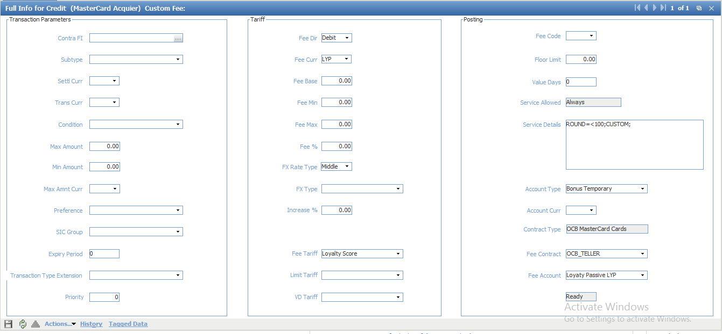

* + Approve with current banking date
* Approve related product service pack with current banking date

1. Setup account scheme

* Navigate ROOT\OpenWay\Full\Configuration Setup\Products\Account Schemes
* Select “MasterCard Credit Private Account”, “JCB Credit Private Account” & Click “Definition” 🡪 Open “Definition for …” form
  + Click “Insert new record”
  + Input values
    - Curr: LYP
    - Account Type: Bonus Available
    - GL Type: Balance
    - GL Number: Client Loyalty Score-990000001
    - Template Details: ROUND=0;
  + Click “Save form changes”
  + Click “Insert new record”
  + Input values
    - Curr: LYP
    - Account Type: Bonus Spending
    - GL Type: Balance
    - GL Number: Client Loyalty Score-990000001
    - Template Details: ROUND=0;
  + Click “Save form changes”
  + Select “Bonus Temporary” & Click “Full Info” 🡪 Open “Full Info for …” form
    - Update values
      * Due Template: Bonus Available
    - Click “Save form changes”
    - Close form
  + Select “Bonus Available” & Click “Full Info” 🡪 Open “Full Info for …” form
    - Update values
      * Due Template: Bonus Spending
      * Due Period: 1
    - Click “Save form changes”
    - Close form